

本科毕业论文（设计）
英 文 翻 译

基于语义的博客支持学习系统

学 院 | 软件工程
姓 名 | 孔浩
专 业 | 软件工程
班 级 | 软件工程142班
学 号 | 2014081052

Semantic Blog Based Supportive Learning System
Abstract—Social networking plays a vital role in todays web. Users of the social network chat, discuss, entertain and watch personal contents in their favorite sites. Most of the users who use the social network are learners and they are very high in numbers. So, it will be an added advantage for the learners to learn from large community where the pool of content is available for learning. The content is available as a blog. Blogs are available in plenty. It becomes a tedious task for the learner to search and find the required content from the large collection of blogs. This work proposes a novel idea to use the social network for creation of blog content for group learning. It uses ontology for a specific subject to relate one blog with another blog. Blog posted for a particular title is related to the blogs of the same blogger or another blogger and it should be linked to the relevant blog. Blogger can also call for online discussion on a posted article which gives the clear picture about the understanding of the topic. Over and above the traditional learning system, a semantic blog based supportive learning system is introduced in this paper. The system yield high result if the user accepts the new learning method. High percentage of interest shown to discuss the topic and easy access and the availability of content is the added advantage.
Keywords—blog; ontology; social learning; community; mind map;
I. INTRODUCTION
In recent years, there is an explosive growth in the use of web-based technology in distance learning systems. Teachers create the learning environment in the web with interesting way to learn. One prominent media is the blog creation. A weblog or blog in short is a special webpage on which an individual author (a blogger) or a group of collaborating authors periodically publish article (entries or posts). Apart from the personal and news articles, blogs are predominantly used for learning. Popular software vendors like oracle [4], IBM [5], Microsoft [6] have their own official blog sites to discuss various new topics of interest. Blogging is applied to knowledge sharing and interactive discussion. Few blog features such as comments, trackbacks, difficulty levels, and association degree related to a specific topic, the best combination of blog articles is produced as a material.
The challenges in the web based learning is first, the learner can only read what the publisher publish or what the learning system shows to the user. Second, the user cannot have the opportunity to discuss his views. Third, learner can learn only the article provided by the faculty or content developer. So our new semantic blog based supportive learning system proposes a novel idea to enhance the teaching learning process over the traditional methods. First, instead of webpage, blogs are created to publish article or a specific topic. Blogs created are indexed in reverse chronological order to the user [4]. Learner who learns the article can comment the blog with his opinion about the article. The learner can also link the blog to his blog site. The system also allows the learner to publish the article with their views. Second, the learner can create a community to discuss about the particular topic. Very useful comments and knowledge is shared by different learner in the community. Blog discussion is very useful for the learners as well as the faculty or the content developers. Third, the social learning system uses an ontology specific to each subject crawl the web to collect more relevant content to enhance the topic discussed in blog to the learner.
This paper provides a supportive learning system in addition to the traditional learning system. Semantic blog based supportive learning system uses subject specific ontology to retrieve blogs relevant to the subject. Part of sample ontology created for subject Operating System(OS) is shown in Fig. 3. It also helps to create relationship to different subject (topic). Faculty can create the mind map which provides clear view about the subject. Fig. 2 shows the mind map of the subject operating system and it is developed using the MindApp [4] tool. Faculty creates blog for each topic as per the mind map. Blog created by faculty is semantically annotated using ontology relationship. User searches for specific topic will get the personalized [17] and ranked blogs. Learner will get the blogs published by the faculty of the subject and additional blogs for that topic published by different researcher (Bloggers).
The contribution of this paper can be summarized as follows.
• Blogs are collected from the web using subject specific ontology.
• Blog creation follows the flow of mind map.
• Semantically annotating the blogs with existing blogs using ontology.
• Supportive learning system which gives personalized and ranked blogs for user search.
The remainder of this paper is organized as follows: Section 2 discusses the related work. Section 3 presents the block diagram of semantic blog based supportive learning system. Section 4 provides experiments and results. Section 5 contains the conclusion and future work
II. RELATED WORK
E-learning is one of the major areas where semantically interlinked contents are expected to be organized thereby intended learners can make use of the facilities. Blogs relating different e-learning categories may be organized in a hierarchical manner with proper indexing. Users who frequently search the blogs may be provided with personalized content based on their user profile [13]. There are several modern authoring systems to develop adaptive educational hypermedia [1] such as InterBook, Web DCG, DCG+GTE, AHA, ACE, ALE, NetCoach/ART-WEB, ECSAIWeb, MetaLinks, SIGUE, etc., all oriented to educational practitioners. Personalized recommender system that uses web mining to recommend the next links to visit in an AIWBES was discussed by Romero.C, et. al. A specific mining tool was developed and a recommender engine in order to help the teacher to carry out the web mining process [2]. Only with a clear sense of the theoretical foundations that underpin assumptions about learning and cognition, can an efficient online learning environment be appropriately designed. These theoretical foundations provide the means to choose an appropriate educational approach. The selection of an approach can be seen as a pre-design concern and is the result of answering basic questions such as why is the environment being developed, what is the focus of the environment and who the learners are [3]. Butterfly model introduced for content development and learning, enables a learner to overcome problems faced with earlier content, and actually helps learners learn concepts better through the various facets available that learners can choose to navigate and the navigation is intuitive and easy for learners to understand [7]. Recommendation and personalization techniques can be classified into three different categories like rule-based filtering systems, content-filtering systems and collaborative filtering systems [8].
Isolated knowledge is useless as it is neither easily retrieved nor easily expanded. Learning concerns internalizing and externalizing knowledge and establishing relations between knowledge of various types and from different sources [9]. Semantic links between resources can be established in two ways: user definition and automatic discovery. Concept map generation technique which is underpinned by a contextsensitive text mining method and a fuzzy domain ontology extraction algorithm can automatically construct concept maps based on the messages posted to an online discussion board [10].
Open Smart Classroom provides a novel experience for both the teacher and students to learn in multiple classrooms. As a prototype learning system, it still has some limitations that need to be enhanced, such as providing more standard specification for new classrooms to join in and improving the aided tools to be more operable and effective. Moreover, how to make full use of the learning environment provided by Open Smart Classroom to enhance students understanding in the multicultural class is still an open question, which needs further studying [11]. NNexus is the first system that automates the process of linking disparate ”encyclopedia” entries into a fully connected conceptual network [12]. The Blogosphere is expanding in an unprecedented speed. A better understanding of the blogosphere can greatly facilitate the development of the Social Web to serve the needs of users, service providers, and advertisers. A prominent feature of the Social Web is that many enthusiastic bloggers voluntarily write, tag, and catalog their posts in order to reach the widest possible audience who will share their thoughts and appreciate their ideas [14].
III. SEMANTIC BLOG BASED SUPPORTIVE LEARNING SYSTEM
Fig. 1 shows the overall block diagram of semantic blog based supportive learning system. It contains online blog collection, preprocessing, faculty blog creation, XML formatting, Blog search. The supportive learning system provides an option to upload subject specific ontology. Crawler is used in the system to crawl the web for each subject and collect the blogs relevant to each subject. Blogs collected may contain non-english and incomplete blogs, which are all removed in the preprocessing stage. Faculties create the subject mind map using the MindApp tool to outline the subject. It gives an overview of the subject.
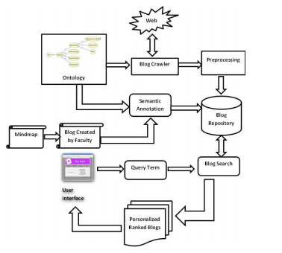
Fig. 1. Semantic Blog Based Supportive Learning System

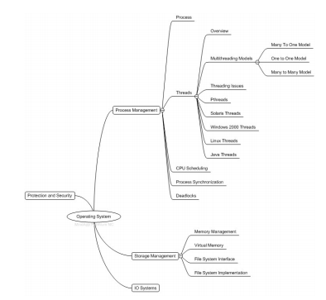
Fig. 2. Simple Mind map for operating system subject

Fig. 2 shows the sample mind map for subject operating system. This in turn gives the functions of operating system, process management, storage management, IO systems, protection and security etc,. Process Management deals with Threads. A thread in turn contains Multithreading Models which has Many to One Model, One to One Model, Many to Many Model. Mind map gives a clear idea of the subject and what it contains. This helps the learners to get an insight of the subject. Blogs are created for each subject according to the mind map and the relationship is created using the ontology. It gives the successor and predecessor of each topic in a subject.Blogs collected and created are converted to common XML format. This facilitates the system with easy retrieval and universal acceptable format. XML formatted blogs contain the xml tags like blogpost, keyword, title, description, url, data, author, tags, frequency and contents. XML formatted blogs are stored in blog repository for learner access.
The learner can access the blog content according to his need. For example if the learner searches for the blog content ’thread’ then all the blogs relevant to the query word from the blog repository is retrieved. Blog retrieved contains the faculty published blogs and the blogs crawled from the web. The learner can suggest the blogs to their friends. They can enter into discussion about the published article. Blog is an excellent interactive space for the teacher and learner. As a result of search the learner will get the personalized and ranked blogs. Ranking is done based on Content Based Importance (CBI) [19]. Our previous work on personalization [17] provides the personalized semantic blogs.
IV. EXPERIMENTS AND RESULTS
Semantic blog based supportive learning system is implemented with sample ontology as shown in Fig. 3. The blogs collected are more relevant and sample blog retrieved for query word operating system is shown in Fig. 4. The system is implemented in a local server to allow access through local network. It is tested with a learner group of 529 students of an engineering college affiliated to Anna University. They give the feedback about the supportive learning system with different perspective.
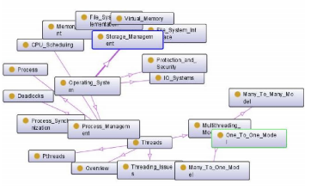
Fig. 3. Sample ontology for operating system subject

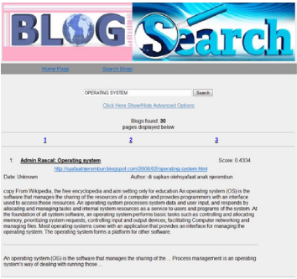
Fig. 4. Sample blogs collected for query word Operating System

Fig. 5 and Fig. 6 shows the bar chart of feedback collected from the students for subject without evolving and with evolving technology. Analysis shows that the students are more interested other than the classroom teaching. These work emphasis the interactive social learning with the traditional learning methodology. Very good number of leaners impressed and reported excellent feedback for the supportive learning system. Analysis clearly says that learners are more interested towards the community learning rather than the classroom learning. Learners are very much interested in the traditional learning for the subject without evolving technology. Fig. 5 clearly shows the view of the learners for the subject probability and statistics, data structures and design and analysis of algorithms. Our system is analyzed with traditional system and Semantic blog based learning system. Our system yield higher 214 number learners interest in subjects with evolving technology. Fig. 6 shows the appreciated number of learners interested in social learning introduced by our supportive learning system.
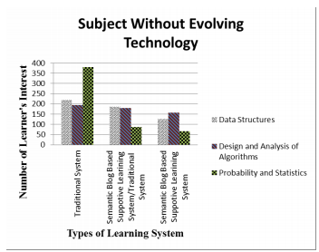
Fig. 5. Learners feedback for subject without evolving technology

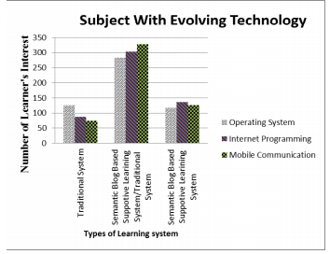
Fig. 6. Learners feedback for subject with evolving technology
V. CONCLUSION AND FUTURE WORK
Semantic blog based supportive learning system shows that the students are more interested in interactive online social learning than the traditional classroom learning. The semantic blog based supportive learning system along with traditional learning system is better than the normal available learning system. So the novel idea is better to implement for interactive social learning for learners. The work can also extended to create community learning for the university subjects like the general topic. This will improve more knowledge sharing among students and faculty. Classle is a social learning system where all students and faculty can gain and share knowledge [18]. Supportive learning system can also accumulate the features of classle learning social network.

REFERENCES
[1] Romero, C., De Bra, P., Palomo, S., Ventura, S., “An Authoring Tool for Web- Based Adaptive and Classic Tests”, World Conference on Elearning in Corporate Government Healthcares and Higher Education, 2004, pp. 174-177.
[2] Romero, C., Ventura, S., Delgado, J.A., De Bra, P., “Personalized Links Recommendation Based on Data Mining In Adaptive Educational Hypermedia Systems”, Proceedings of the second European Conference on Technology Enhanced Learning, EC-TEL 2007, Springer LNCS, Crete, 2007.
[3] Nunes, J.M. , “The Experiential Dual Layer Model (EDLM): A Conceptual Model Integrating a Constructivist Theoretical Approach to Academic Learning with the Process of Hypermedia Design.”, Sheffield: PhD Thesis, University of Sheffield, Department of Information Studies (1999).
[4] https://blogs.oracle.com/
[5] http://www.ibm.com/blogs/zz/en
[6] http://sharepoint.microsoft.com/blog/Pages/default.aspx
[7] Surya Kiran Reddy Karri, Sandhya Kode, “Butterfly model: An innovative way to deliver and personalize content in the Learning by Doing methodology”, IEEE International Conference on Technology for Education (T4E), 14-16 July 2011, Chennai, India, pp 103-108.
[8] Mobasher, B., “Data Mining for Personalization. In The Adaptive Web: Methods and Strategies of Web Personalization”, Brusilovsky, P., Kobsa, A., Nejdl, W. (eds.). Springer- Verlag, Berlin Heidelberg (2007) 1-46.
[9] Hai Zhuge, “Communities and Emerging Semantics in Semantic Link Network: Discovery and Learning”, IEEE Transactions on Knowledge and Data Engineering, Vol. 21, No. 6, June 2009, pp 785-799.
[10] Raymond Y.K. Lau, Dawei Song, Yuefeng Li, Terence C.H. Cheung and Jin-Xing Hao, “Toward a Fuzzy Domain Ontology Extraction Method for Adaptive e-Learning”, IEEE Transactions on Knowledge and Data Engineering, Vol. 21, No. 6, June 2009, pp 800-813.
[11] Yue Suo, Naoki Miyata, Hiroki Morikawa, Toru Ishida, and Yuanchun Shi, “Open Smart Classroom: Extensible and Scalable Learning System in Smart Space Using Web Service Technology”, IEEE Transactions on Knowledge and Data Engineering, Vol. 21, No. 6, June 2009, pp 814- 828.
[12] James Gardner, Aaron Krowne, and Li Xiong, NNexus, “An Automatic Linker for Collaborative Web-Based Corpora”, IEEE Transactions on Knowledge and Data Engineering, Vol. 21, No. 6, June 2009, pp 829- 839.
[13] S.Godfrey Winster and Dr.S.Swamynathan, “Personalized Blog Search in Social Grid for E-Learning”, Proceeding of International Conference on Computing Technologies (ICONCT09), Sivakasi, India, December, 2009, pp 423-428.
[14] Nitin Agarwal, Magdiel Galan , Huan Liu , Shankar Subramanya, “WisColl: Collective wisdom based blog clustering”, Journal of Information Sciences 180 (2010) 3961.
[15] Yun Chi, Belle L. Tseng, Junichi Tatemura. (2006), “Eigen-Trend: Trend analysis in the Blogosphere based on singular value decompositionsPersonalized Semantic Based Blog Retrieval”, Proceedings of the International Conference on Information and Knowledge Management, Arlington, Virginia, USA, pp. 391-397.
[16] www.mindapp.com
[17] S. Godfrey Winster and Dr.S.Swamynathan, “Personalized Semantic Based Blog Retrieval”, Journal of computer science and Technology, Vol. 27, No. 3, May 2012, pp 591-598.
[18] http://www.classle.net/
[19] Sandor Dominich, (2008), “The Modern Algebra of Information Retrieval”, Springer-Verlag Berlin Heidelberg

…
…
…

基于语义的博客支持学习系统
抽象社交网络在今天的网络中扮演着至关重要的角色。社交网络的用户在他们喜欢的网站上聊天、讨论、娱乐和观看个人内容。大多数使用社交网络的用户都是学习者，而且他们的数字非常高。所以，这将是一个额外的优势，让学习者从大的社区学习，那里的内容是可以学习的。内容可用作博客。博客有很多。对于学习者来说，从大量的博客中搜索和查找所需要的内容已经成为一项乏味的任务。这项工作提出了一个新的想法，利用社交网络创建博客内容进行群组学习。它使用本体为一个特定的主题将一个博客与另一个博客联系起来。一个特定标题的博客与同一博客或另一个博主的博客相关，应该链接到相关的博客。博主也可以要求在线讨论一篇文章，这篇文章给出了对这个主题的理解的清晰图片。在传统的学习系统之上，本文介绍了一种基于语义博客的支持学习系统。如果用户接受新的学习方法，系统就会产生很高的结果。在讨论主题和容易访问以及内容的可用性方面，高百分比的兴趣是额外的优势。

Keywords-blog;本体;社会学习;社区;思维导图;

一.引言
近年来，网络技术在远程教育系统中的应用呈爆炸式增长。教师通过有趣的方式在网络中创造学习环境。一个著名的媒体就是博客的创作。一个博客或博客是一个特别的网页，一个单独的作者(一个博主)或一组合作作者定期发表文章(条目或文章)。除了个人和新闻文章，博客主要用于学习。像oracle[4]、IBM[5]、微软[6]等受欢迎的软件供应商都有自己的官方博客网站，讨论各种各样的新话题。博客应用于知识共享和交互式讨论。很少有像评论、trackback、难度级别、与特定主题相关的关联程度之类的博客功能，博客文章的最佳组合是作为一种材料生成的。

基于web的学习的挑战首先是，学习者只能阅读发布者发布的内容或学习系统向用户展示的内容。其次，用户不能有机会讨论他的观点。第三，学习者只能学习由教师或内容开发人员提供的文章。因此，我们新的基于语义博客的支持学习系统提出了一种新颖的方法来加强传统方法的教学学习过程。首先，不是网页，而是博客。创建用于发布文章或特定主题。创建的博客按时间顺序对用户进行索引[4]。学习这篇文章的学习者可以用他对文章的观点来评论博客。学习者还可以将博客链接到他的博客网站。该系统还允许学习者以自己的观点发表文章。第二，学习者可以创建一个社区来讨论特定的主题。在社区中，不同的学习者会分享非常有用的评论和知识。博客讨论对学习者和教师或内容开发者都非常有用。第三，社会学习系统使用一个专门针对每个主题的本体论，来收集更多相关的内容，以提高博客对学习者所讨论的话题。

除了传统的学习系统外，本文还提供了一个辅助学习系统。基于语义的博客支持学习系统使用主题特定的本体检索与主题相关的博客。为subject操作系统(OS)创建的示例本体的一部分如图3所示。它还有助于创建与不同主题(主题)的关系。教师可以创建思维导图，提供关于这个主题的清晰的观点。图2显示了主题操作系统的思维图，它是使用MindApp[4]工具开发的。教师根据思维导图为每个主题创建博客。由教师创建的博客使用本体关系进行语义标注。用户对特定主题的搜索将会得到个性化的[17]，并对博客进行排名。学习者将会得到由不同研究人员(博主)发表的主题和其他博客的博客。

本文的贡献可以概括如下。

•使用主题特定的本体从web上收集博客。
•博客创作遵循思维导图的流程。
•用现有的博客对博客进行语义标注。
•支持性学习系统，提供个性化服务，为用户提供搜索排名的博客。

本文的其余部分组织如下:第2节讨论相关的工作。第3节给出了基于语义博客的支持性学习系统框图。第4节提供实验和结果。第5节包含结论和未来的工作。

二.相关工作

电子学习是一个主要的领域，其中语义互连的内容预计将被组织，从而有意学习者可以利用这些设施。有关不同电子学习类别的博客可以以分级方式组织，并有适当的索引。经常搜索博客的用户可以根据他们的用户配置文件提供个性化的内容[13]。有几个现代的创作系统开发自适应的教育超媒体[1]，如InterBook, Web DCG, DCG+GTE, AHA, ACE, ALE, NetCoach/ART-WEB, ECSAIWeb, MetaLinks, SIGUE等，都面向教育从业者。Romero讨论了一个个性化的推荐系统，它使用web挖掘来推荐下一个到AIWBES访问的链接。为了帮助教师进行web挖掘过程[2]，开发了一个特定的挖掘工具和一个推荐引擎。只有对支撑学习与认知假设的理论基础有清晰的认识，才能设计出一个高效的在线学习环境。这些理论基础提供了选择适当的教育方法的方法。选择一种方法可以被看作是一个预先设计的问题，它是回答一些基本问题的结果，例如为什么环境正在发展，环境的重点是什么，学习者是谁[3]。为内容开发和学习而引入的蝴蝶模型，使学习者能够克服早期内容所面临的问题，并通过学习者可以选择的各个方面来帮助学习者更好地学习概念，使学习者更容易理解[7]。推荐和个性化技术可以分为三类，如基于规则的过滤系统、内容过滤系统和协同过滤系统[8]。

孤立的知识是无用的，因为它既不容易获取，也不容易扩展。学习关注内化和外化知识，并建立不同类型和不同来源的知识之间的关系[9]。资源之间的语义链接可以通过两种方式建立:用户定义和自动发现。基于上下文敏感的文本挖掘方法和模糊领域本体提取算法支持的概念图生成技术可以根据发布到在线讨论板上的消息自动构建概念图[10]。

开放式智能教室为教师和学生在多间教室学习提供了一种全新的体验。作为一个原型学习系统，它仍然有一些需要加强的限制，例如为新教室提供更多的标准规范，以加入和改进辅助工具，使其更加可操作和有效。此外，如何充分利用开放智能课堂提供的学习环境，提高学生对多元文化课堂的理解仍是一个有待进一步研究的开放性问题[11]。NNexus是第一个自动化的系统，将不同的“百科全书”条目连接到一个完全连接的概念网络的过程[12]。

博客圈正在以前所未有的速度扩张。更好地了解博客圈可以极大地促进社会网络的发展，以满足用户、服务提供者和广告商的需求。社交网络的一个显著特点是，许多热心的博客作者自愿地写、标记和编录他们的文章，以达到尽可能多的读者分享他们的想法[14]。

三.基于语义的博客的支持的学习系统

图1为基于语义博客的支持性学习系统整体框图。它包含在线博客收集、预处理、教师博客创建、XML格式、博客搜索。支持学习系统提供了一个上传主题特定本体的选项。爬虫在系统中用于抓取每个主题的网络，并收集与每个主题相关的博客。收集的博客可能包含非英语和不完整的博客，这些都在预处理阶段被删除。教员利用MindApp工具创建主题思维导图来概括主题。它概述了这个主题。

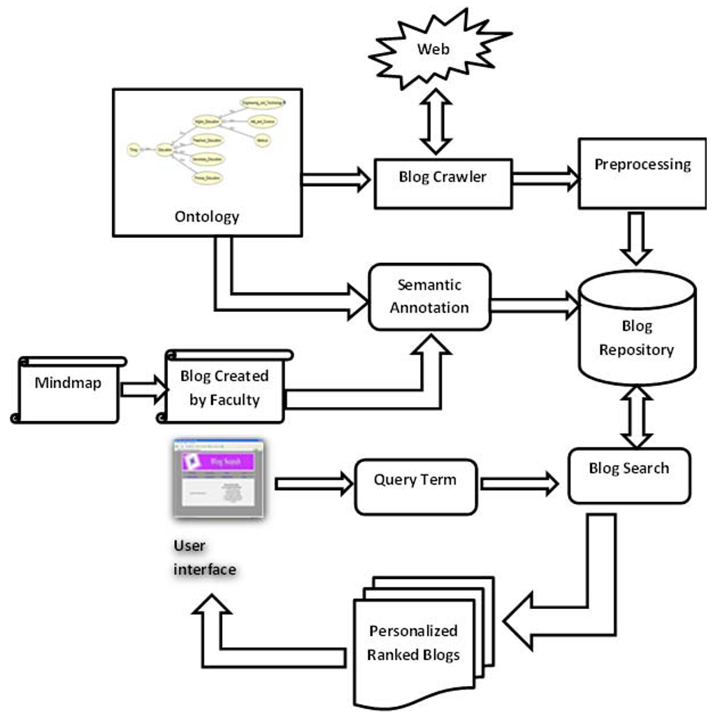
图1、基于语义的博客支持学习系统。

图2显示了主题操作系统的样本思维图。这又提供了操作系统、过程管理、存储管理、IO系统、保护和安全等功能。流程管理处理线程。一个线程依次包含多个线程模型，其中有多个模型，一个模型，多个模型。Mind map给出了这个主题的一个清晰的概念。

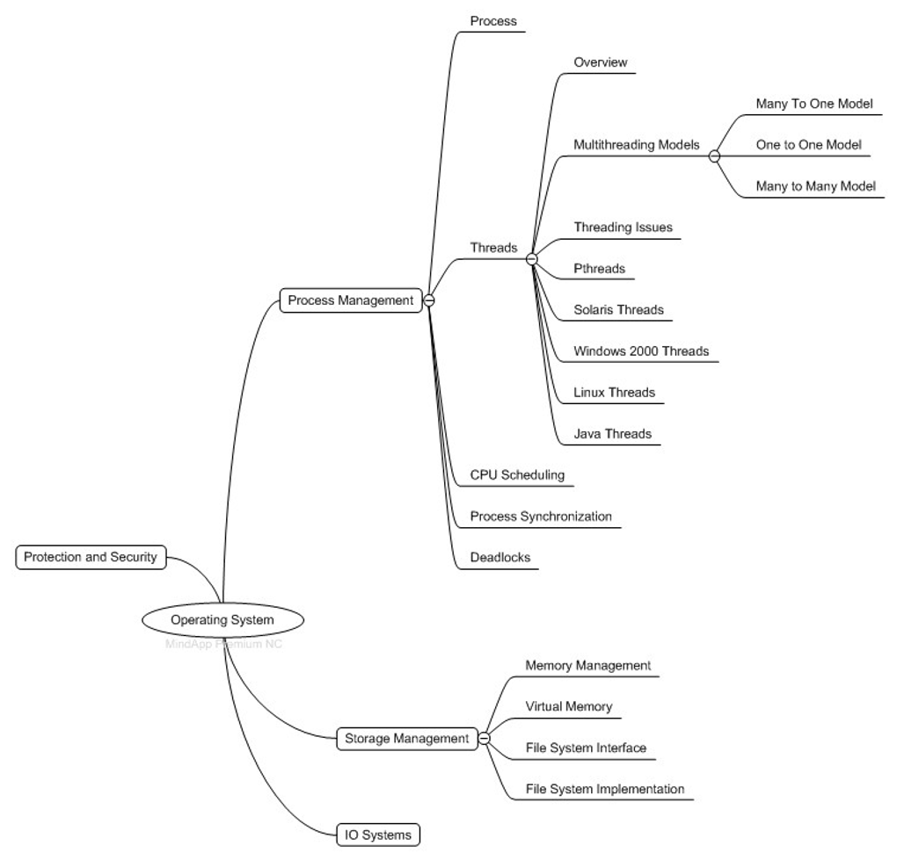
图2、操作系统主题简单思维导图。

这有助于学习者了解这个主题。根据思维导图，为每个主题创建博客，并使用本体创建关系。它给出了主题中每个主题的继承和前身。收集和创建的博客都转换为通用的XML格式。这使得系统易于检索和普遍接受的格式。XML格式的博客包含诸如blogpost、关键字、标题、描述、url、数据、作者、标签、频率和内容等XML标签。XML格式的博客存储在博客存储库中以供学习者访问。

学习者可以根据自己的需要访问博客内容。例如，如果学习者搜索博客内容的“线程”，那么将检索与博客存储库中查询词相关的所有博客。检索到的博客包含了教员发表的博客，博客也从网络上爬了出来。学习者可以向他们的朋友推荐博客。他们可以讨论已发表的文章。博客是一个很好的互动空间，为老师和学习者。由于搜索的结果，学习者将得到个性化和排名的博客。排名是基于基于内容的重要性(CBI)[19]。我们之前关于个性化的研究[17]提供了个性化的语义博客。

四．实验和结果

基于语义博客的支持学习系统是用样本本体实现的，如图3所示。所收集的博客更相关，查询词操作系统检索的样本博客如图4所示。该系统在本地服务器中实现，以允许通过本地网络访问。在安娜大学附属工程学院的529名学生中进行了测试。他们给出了关于支持性学习系统的反馈和不同的观点。图5和图6显示了收集的反馈条形图。

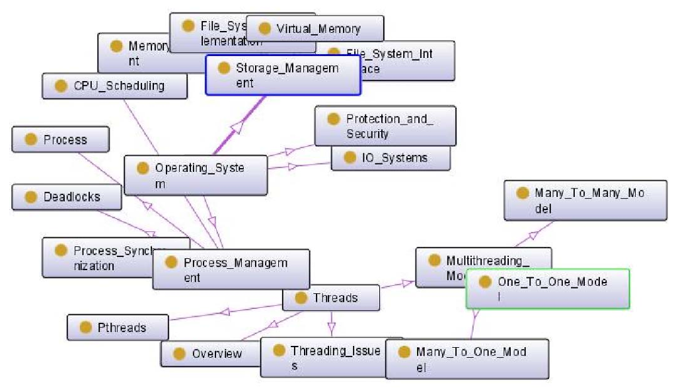
图3、操作系统主题的示例本体。

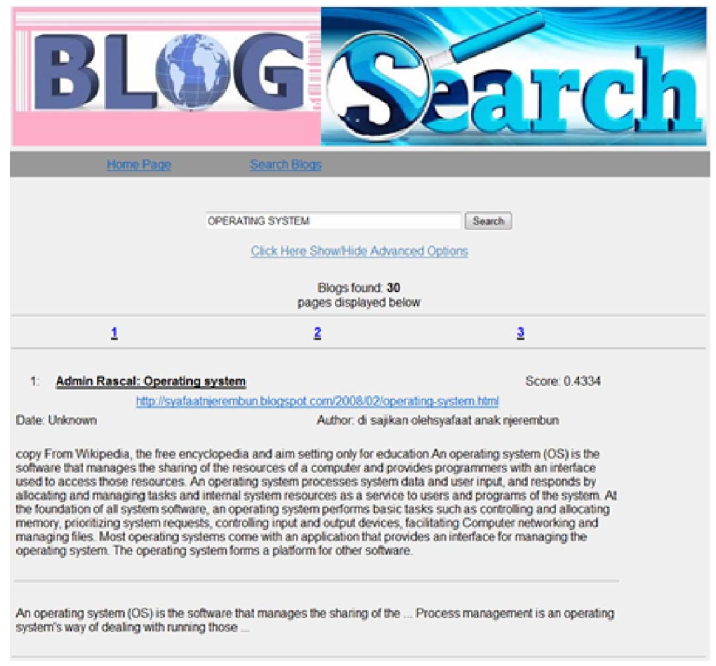
图4、为查询词操作系统收集的示例博客。

从学生到学科，没有进化和发展的技术。分析表明，学生对课堂教学的兴趣大于课堂教学。这些工作强调了与传统学习方法的交互社会学习。非常多的瘦身者对支持性学习系统印象深刻并报告了优秀的反馈。分析表明，学习者对社区学习更感兴趣，而不是课堂学习。学习者对传统的学习兴趣浓厚，而不需要发展技术。图5清晰地显示了学习者对主体概率和统计、数据结构和算法的设计和分析的看法。我们的系统是用传统的系统和基于语义的博客系统来分析的。我们的系统产生高数字学习者对不断发展的技术感兴趣。图6显示了我们支持的学习系统对社会学习感兴趣的学习者的数量。

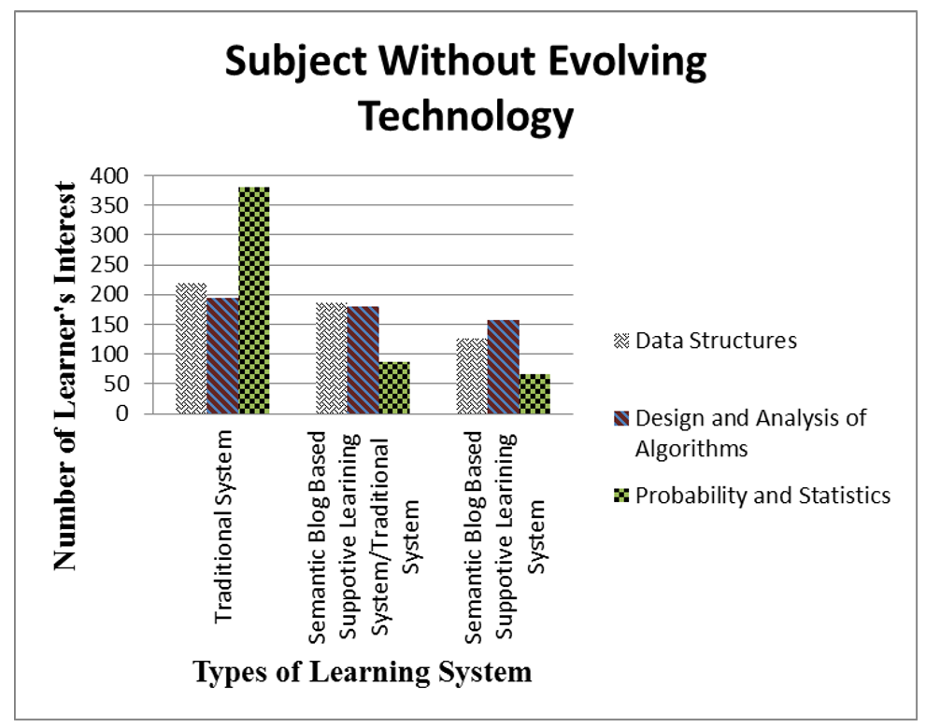
图5、学习者在没有进化技术的情况下对主题进行反馈。

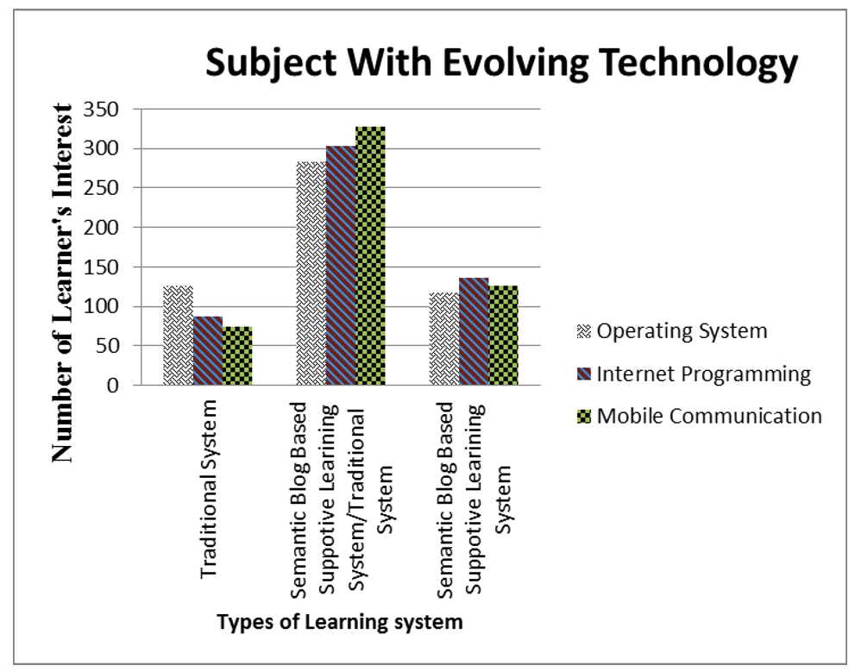
图6、学习者对技术进步的反馈。

五、结论与未来工作。

基于语义博客的支持学习系统表明，学生对互动式在线社交学习的兴趣大于传统的课堂学习。基于语义博客的支持学习系统和传统的学习系统比正常的可用学习系统要好。因此，对于学习者而言，新颖的思想更适合于交互式的社会学习。这项工作还可以扩展到像普通主题这样的大学主题的社区学习。这将提高学生和教师之间的知识共享。Classle是一种社会学习系统，所有的学生和教师都可以获得和分享知识[18]。辅助性学习系统也可以积累课堂学习社交网络的特点。

参考文献

[1]罗梅罗,C。戴胸罩,P。、Palomo年代。文图拉,S。“一个基于Web的自适应和经典测试的创作工具”，世界电子会议。《企业政府健康与高等教育的学习》第174-177页。

[2]罗梅罗,C。文图拉,S。戴尔嘎多,正当戴胸罩,P。，“基于数据挖掘的个性化链接推荐”。“超媒体系统”，第二届欧洲技术增强学习会议论文集，ectel 2007，施普林格LNCS, Crete, 2007。

[3]Nunes, J.M.，“经验双层模型(EDLM):一个整合建构主义理论方法的概念模型。
学术学习与超媒体设计的过程。谢菲尔德:谢菲尔德大学博士论文(1999年)。

[4]https://blogs.oracle.com/
[5]http://www.ibm.com/blogs/zz/en
[6]http://sharepoint.microsoft.com/blog/Pages/default.aspx
[7]Surya Kiran Reddy Karri, Sandhya Kode， " Butterfly模型:An in-。"
2011年7月14日至16日，印度钦奈(印度)第103-108页，《教育技术与教育技术国际会议》(T4E)。

[8]Mobasher B。，“数据挖掘的个性化。在自适应Web: Web个性化的方法和策略”，Brusilovsky, P。Kobsa,、Nejdl w(eds)。施普林格- Verlag，柏林海德堡(2007)1-46。

[9]Hai zbig，“语义链接网络中的社区与新兴语义:发现与学习”，IEEE知识交易。和数据工程，第21卷，第6期，2009年6月，第785-799页。

[10]Raymond Y.K. Lau, Dawei Song, Yuefeng Li, Terence C.H.张和Jin-Xing Hao，“走向一个模糊的领域本体提取方法”。“自适应电子学习”，IEEE知识与数据工程学报，第21卷，第6期，2009年6月，第800-813页。

[11]月朔、宫崎骏、森川博、石田和释永春，“开放智能课堂:可扩展的、可伸缩的学习系统。”在智能空间使用Web服务技术“，IEEE知识与数据工程学报，第21卷，第6期，2009年6月，第814-828页。

[12]James Gardner, Aaron Krowne，和Li Xiong, NNexus，“基于网络的协同合作的自动链接器”，IEEE的交易。知识与数据工程，第21卷，第6期，2009年6月，第829-839页。

[13]。戈弗雷Winster和博士。Swamynathan，“个性化的博客搜索在社会网格中的电子学习”，国际会议的进程。关于计算技术(ICONCT09)， Sivakasi，印度，2009年12月，第423-428页。

[14]Nitin Agarwal, Magdiel Galan, Huan Liu, Shankar Subramanya，“Wis-Coll:集体智慧博客集群”，信息杂志。

